

JOSE RIZAL MEMORIAL STATE UNIVERSITY
The Premier University in Zamboanga del Norte
Main Campus Dapitan City

IRONGRIND: A FITNESS GYM MEMBERSHIP AND OPERATIONS MANAGEMENT SYSTEM

A Capstone
Presented to the
Faculty of the College of Computing Studies
JOSE RIZAL MEMORIAL STATE UNIVERSITY
The Premier University in Zamboanga del Norte
Main Campus, Dapitan City

In Partial Fulfillment
of the Requirements for the Degree
BACHELOR OF SCIENCE IN INFORMATION SYSTEMS

BONGCAO, JAMAICA H.
CASTRO, GLENERINE MAE I.
GOMEZ, ROSHE MAE I.
SERIPA, ANA JEAN D.

April 2026



Republic of the Philippines
JOSE RIZAL MEMORIAL STATE UNIVERSITY
The Premier University in Zamboanga del Norte
Main Campus, Dapitan

C E R T I F I C A T I O N

This is to certify that Jamaica H. Bongcao, Glenerine Mae I. Castro, Roshe Mae I. Gomez, and Ana Jean D. Seripa, are enrolled in IS 412 (Capstone 2) for the degree of Bachelor of Science in Information Systems during the second semester, School Year 2025-2026.

MEDELYN S. GAHUMAN, MIS
Research Professor

The capstone entitled IronGrind: A fitness Gym Membership and Operations Management System prepared and submitted by Jamaica H. Bongcao, Glenerine Mae I. Castro, Roshe Mae I. Gomez, and Ana Jean D. Seripa has been examined, checked, and recommended for final defense.

MEDELYN S. GAHUMAN
Adviser

Republic of the Philippines
JOSE RIZAL MEMORIAL STATE UNIVERSITY
The Premier University in Zamboanga del Norte
Main Campus, Dapitan

APPROVAL SHEET

This Capstone entitled “IronGrind: A fitness Gym Membership and Operations Management System” has been prepared and submitted by by Jamaica H. Bongcao, Glenerine Mae I. Castro, Roshe Mae I. Gomez, and Ana Jean D. Seripa. It has been reviewed and is recommended for acceptance and approval for final defense on ___________.

MEDELYN S. GAHUMAN, MIS
Capstone Adviser

Approved by the committee in ORAL EXAMINATION on ______________ with the PANEL OF EXAMINERS.
PANEL OF EXAMINERS

___________________________ ____________________________
Member Member

_______________________
Chairperson

Accepted and approved in partial fulfillment for the degree of Bachelor of Science in Information Systems during the second semester, AY 2025-2026 by the Associate Dean of the College of Computing Studies.

JOHN D. SAGAPSAPAN, MSIT
Associate Dean, College of Computing Studies

Chapter 1
INTRODUCTION

Background of the Study
The increasing use of information technology has transformed how businesses manage their daily operations, maintain records, and deliver services to customers. In the fitness industry, gym establishments perform various administrative activities, including membership registration, attendance monitoring, payment recording, inventory management, and report preparation. These activities require accurate and organized information to ensure efficient operations and reliable service delivery. As the number of transactions and membership records increases, the use of computerized management systems becomes an important consideration for establishments seeking to improve their administrative processes.
Several gym management systems have been developed to support the operational requirements of fitness establishments. For instance, GymMaster reports more than 180,000 active weekly users across over 90 countries (GymMaster, n.d.). Similarly, GYMMANAGER reports operations in 22 countries and more than 600 automated gyms, offering features such as membership management, booking, payment processing, access control, and artificial intelligence-assisted business insights (GYMMANAGER, n.d.-a, n.d.-b). These platforms demonstrate the application of information systems in managing gym operations, particularly in organizing membership records, monitoring attendance, and processing business transactions.
Despite the availability of digital management solutions, establishments that rely on manual recordkeeping may encounter difficulties in maintaining accurate and accessible information. Paper-based registration forms, attendance logbooks, receipts, and separate files can make record retrieval time-consuming and increase the possibility of incomplete, duplicated, or misplaced information. These limitations may affect the efficiency of administrative activities, particularly when staff need to verify membership status, update transactions, monitor attendance, or prepare reports. The use of separate recording methods may also make it difficult to maintain consistent information across different operational activities.
Iron Grind Fitness Gym, located in Purok Mangga, Sulangon, Dapitan City, Zamboanga del Norte, provides fitness services to individuals with varying fitness goals. The establishment offers membership plans, fitness-related guidance, supplements, and gym merchandise. Its daily operations involve managing member registrations, processing membership renewals, recording payments, monitoring attendance, maintaining product inventory, and documenting sales transactions. These interconnected activities require systematic recordkeeping to support the gym owner and staff in managing the establishment effectively.
One of the operational concerns of Iron Grind Fitness Gym involves the management of membership information and transactions. When registration details, membership renewals, payment records, and membership periods are maintained through paper forms or separate files, staff may experience difficulties in organizing and retrieving information. Verifying whether a member has an active membership, confirming renewal payments, and determining membership expiration dates may require checking multiple records. Manual updating of membership information may also result in incomplete records, inconsistent entries, and delays in processing member transactions. These concerns highlight the need for a more organized approach to managing membership information and maintaining accurate membership histories.
Attendance monitoring presents another operational concern. The use of handwritten attendance logbooks may result in unclear, duplicated, or missing entries, making it difficult to maintain accurate records of members' check-ins and check-outs. Staff may need to review attendance records manually when verifying member visits or preparing attendance reports. Without a centralized attendance monitoring mechanism, retrieving historical attendance information and ensuring consistency between attendance and membership records may become challenging.
In addition to membership and attendance management, the gym also handles the sale of supplements and merchandise. Its inventory includes powder, liquid, capsule, and tablet supplements tracked using the applicable weight, volume, piece, or box units, and merchandise such as shirts available in different sizes. Maintaining these products through manual inventory and sales records may create difficulties in monitoring available quantities, recording transactions, and identifying items that require restocking. Since the establishment processes payments in person rather than through an online payment facility, it also requires an organized recording mechanism that supports its existing payment procedures while maintaining accurate sales and inventory information.
The interconnected nature of these operational concerns emphasizes the need for a centralized information system that can integrate membership management, attendance monitoring, payment recording, inventory management, and reporting. Although commercial gym management platforms provide similar functionalities, Iron Grind Fitness Gym requires a solution designed around its specific operational processes, including administrator-approved membership applications and renewals, staff-operated attendance recording, inventory tracking using product-appropriate units, and the recording of in-person transactions.
To address these concerns, the proponents developed IronGrind: A Fitness Gym Membership and Operations Management System. The system provides online membership registration, membership application review and approval, membership status monitoring, renewal requests, and member record management. It also incorporates QR code-based attendance monitoring, allowing authorized staff to record member check-ins and check-outs. Members can access their dashboard to view their membership status, remaining membership period, attendance history, and QR code.
Furthermore, the system supports product inventory management, sales recording, membership transaction monitoring, and report generation. Its inventory features accommodate supplements monitored by weight, volume, piece, or box, as appropriate, and merchandise monitored by item and stock quantity. The system maintains the gym's existing in-person payment process while providing a digital mechanism for recording transactions. Supabase is utilized for authentication and database management, with role-based access controls to support the appropriate use of administrator, staff, and member functions.
Through the development of IronGrind, the proponents aim to provide a web-based information system that addresses the operational needs of Iron Grind Fitness Gym. By integrating its essential administrative activities into a centralized platform, the system is intended to minimize difficulties associated with manual recordkeeping, improve the organization and retrieval of information, support accurate membership and attendance monitoring, and facilitate inventory and transaction management. Ultimately, the project seeks to provide a practical and accessible technological solution that supports more efficient gym operations and improved service delivery to its members.

Statement of the Problem
At present, gym operations involving member registration, membership renewals, payment recording, attendance monitoring, and supplement and merchandise sales may be handled through manual records such as logbooks, paper forms, receipts, and separate files. Member information, including contact details, membership plan, payment status, membership dates, and membership status, may be difficult to organize and retrieve when records are not maintained in one centralized system. This can result in delayed transactions, incomplete records, misplaced documents, and errors when updating information.
One major challenge is monitoring membership information, payments, and renewal requests. The administrator needs to review member records, determine membership status, confirm payment records, and monitor expiration dates. Members may submit renewal requests at any time, but each request must be reviewed by the admin before it takes effect. When records are managed manually, checking these details may take time and affect the speed of customer service. Attendance monitoring through a handwritten logbook can also lead to unclear, duplicate, incomplete, or missing entries.
Supplement and merchandise inventory and sales are also important in the daily operations of Iron Grind Fitness Gym. The gym sells supplements using product-appropriate weight, volume, piece, or box units and merchandise, such as shirts, by item and stock quantity. Manual records may make it difficult for the gym admin to monitor available quantities, record purchases accurately, identify items that need restocking, and review sales information for members and walk-in customers. Since the gym handles payments in person, it also needs an organized way to record completed transactions and provide receipts.
The IronGrind: A Fitness Gym Membership and Operations Management System was developed to address these concerns. The system brings together member and membership management, registration and renewal application review, payment recording, QR code-based attendance monitoring, product inventory, in-person sales transactions, and reports in one web-based platform.
The system organizes member profiles, membership plans, membership dates, and membership status. It allows applicants to submit registration details online for admin review and allows existing members to submit renewal requests at any time. A renewal takes effect only after admin approval. If the membership is still active, unused time is carried forward from its current expiry date; if it has expired, the renewed period starts on the approval date.
The system also assigns a QR code to each member. Authorized staff can scan the code to record a member’s check-in or check-out. Members can access their dashboard to view their membership status, membership-period progress, attendance history, and QR code.
Furthermore, the system allows the gym admin to manage supplements tracked using product-appropriate units and merchandise tracked by item and stock quantity. It records in-person sales for members and walk-in customers and generates receipts for completed transactions. The system organizes membership, payment, attendance, inventory, and sales information into reports for the gym admin. It does not process payments online.
Therefore, this study aimed to develop a web-based system for Iron Grind Fitness Gym that organizes its membership and operational records. Through the IronGrind system, the gym admin can manage member information, review applications and renewal requests, record attendance and in-person transactions, monitor inventory, and review reports. This can reduce reliance on separate manual records and support more organized day-to-day operations.

Objectives
The goal of this study was to design and develop IronGrind: A Fitness Gym Membership and Operations Management System for Iron Grind Fitness Gym. The system addresses the need to organize member information, membership applications and renewals, payments, attendance, product inventory, sales transactions, and reports.
Specifically, the proponents aimed to:
- To develop a member and membership management feature that creates a centralized database for member profiles, contact information, membership plans, membership start dates, expiration dates, and active or expired membership status.
- To develop online registration and renewal request features that allow administrators to review, approve, or reject applications. Members may submit renewal requests at any time, but renewals take effect only after administrator approval. An active membership carries forward unused time, while an expired membership restarts on the approval date.
- To develop a QR code-based attendance monitoring feature that allows authorized staff to record member check-ins and check-outs.
- To develop a product inventory and sales feature that manages supplements tracked by weight, volume, piece, or box, as appropriate, and merchandise tracked by item and stock quantity, and records in-person transactions for members and walk-in customers.
- To develop a reporting feature that organizes system data into separate membership, payment, attendance, inventory, and sales reports, allowing the gym admin to monitor each area of operations individually.

Scope and Delimitation
The study focused on the development of IronGrind: A Fitness Gym Membership and Operations Management System for Iron Grind Fitness Gym. The system provided a centralized platform for managing member profiles, membership applications and renewals, payments, attendance, product inventory, sales transactions, and reports.
The system stored and organized member profiles and membership information, including membership plans, start dates, expiration dates, and membership status. Applicants could submit registration details online for administrator review. Members could submit renewal requests at any time, but each request required administrator approval. When an active membership was renewed, unused time was carried forward from its current expiry date. When a membership had expired, the renewed period started on the approval date.
The system included a QR code-based attendance monitoring feature. Each member was assigned a QR code that authorized administrators and staff could scan to record check-ins and check-outs using a computer camera or a supported phone camera. Phone scanning required an authorized operator account, with phone pairing managed through the administrator interface. The system stored attendance records for reviewing member visits.
The system also included product inventory and sales features. Supplements were tracked by weight, volume, piece, or box, as appropriate, while merchandise was tracked by item and stock quantity. The gym admin could manage product information and record in-person sales for members and walk-in customers. The system could generate receipts for completed transactions. Payments were handled at the gym; the system did not process payments online.
The system included a reporting feature that organized membership, payment, attendance, inventory, and sales information into separate reports for the gym admin to review.
The primary users of the system were the gym administrator, authorized staff, and registered gym members. The administrator managed member records, applications, renewals, attendance, inventory, sales, staff accounts, activity logs, and reports. Authorized staff could record attendance, register walk-in members, process direct membership renewals and plan changes, and record product sales through their assigned functions. Online applications and renewal requests remained subject to administrator review. Members could view their membership information, membership-period progress, attendance history, and QR code, browse available products, and submit renewal requests. Walk-in customers could have in-person product purchases recorded without using member accounts.
The system was limited to Iron Grind Fitness Gym. It did not connect to other gyms, external stores, online payment gateways, banks, or mobile wallet services. It did not provide product reservations, AI-based workout or supplement recommendations, medical advice, or automated fitness coaching. Membership progress referred to the time remaining in a membership period and did not measure workout performance or physical changes.

Significance of the Study
The IronGrind: A Fitness Gym Membership and Operations Management System addressed the need to organize member records, membership applications and renewals, payments, attendance, inventory, and sales transactions.
Gym Owner and Admin of Iron Grind Fitness Gym. The system benefited the gym owner and admin by providing access to organized member profiles, membership records, applications, renewals, attendance logs, inventory information, sales transactions, and reports. It helped the admin retrieve records, monitor membership status, record in-person payments, manage products, and review each area of gym operations.
Gym Members. Members benefited from access to their membership information, membership-period progress, attendance history, and QR code through the member dashboard. They could also submit renewal requests online for administrator review.
Walk-in Customers. Walk-in customers benefited from having their in-person product purchases recorded and receipts generated for completed transactions.
Organization: Iron Grind Fitness Gym. The system provided a centralized way to manage the gym’s membership and daily operational records. By organizing applications, renewals, attendance, inventory, sales, and reports, it supported more consistent recordkeeping and service.
Future Researchers. This study may serve as a reference for future researchers developing web-based systems for gym membership and operations management. Future studies may explore additional features, such as online payment integration or expanded mobile application capabilities, if these are needed and developed.

Definition of terms
Administrator. An authorized user responsible for reviewing applications and managing member, attendance, inventory, sales, and report records.
Authorized Staff. A user assigned a staff account to record attendance, register walk-in members, process direct membership renewals and plan changes, and record in-person product sales within the access allowed by the system.
Gym Member. A registered individual with a member account and recorded membership information.
Membership Application. An online submission from a prospective member that awaits administrator review.
Membership History. A record of membership events, including renewals, plan changes, and expired membership periods.
Membership Progress. A dashboard display showing the time remaining in a member’s recorded membership period.
Membership Renewal Request. A request submitted by an existing member to renew their membership. It may be submitted at any time and takes effect only after administrator approval. An active membership carries forward unused time, while an expired membership restarts on the approval date.
Printed Receipt. A receipt generated by the system for a completed in-person transaction and printed for the customer.
QR Code-Based Attendance Monitoring. The recording of a member’s check-in or check-out when authorized staff scan the member’s QR code.
Reporting Feature. A feature that organizes membership, payment, attendance, inventory, and sales information into separate reports for the gym admin.
Walk-in Customer. An individual who purchases gym products without using a registered member account.

Relevance to Sustainable Development Goals (SDGs)
The development of IronGrind: A Fitness Gym Membership and Operations Management System relates to the Sustainable Development Goals through its support for organized gym operations and digital recordkeeping. In relation to SDG 3, Good Health and Well-being, the system supports the administration of gym services by helping members access their membership information and enabling authorized personnel to record attendance. It does not provide medical advice or fitness coaching. For SDG 8, Decent Work and Economic Growth, its organized membership, inventory, sales, and reporting records can support routine administrative work and operational review. In relation to SDG 9, Industry, Innovation, and Infrastructure, IronGrind applies web-based technology to the operational needs of a local fitness establishment. The system also relates to SDG 12, Responsible Consumption and Production, by supporting digital membership, attendance, payment, and inventory records that can reduce reliance on paper forms and logbooks. These connections describe the intended contribution of the system rather than measured outcomes of SDG achievement.

Chapter 2
REVIEW OF RELATED LITERATURE AND STUDIES

The Review of Related Literature presents existing studies, frameworks, and systems relevant to gym membership, attendance monitoring, inventory management, and operations within fitness establishments. It highlights international, national, and local research that identifies both the benefits and challenges of adopting digital solutions for membership administration, attendance tracking, and sales management. By examining prior work, this section establishes the foundation for the proposed IronGrind: A Fitness Gym Membership and Operations Management System for Iron Grind Fitness Gym in Purok Mangga, Sulangon, Dapitan City, Zamboanga del Norte, situating the study within broader efforts to improve efficiency, accuracy, and record integrity in local fitness operations.

Related Literature
Gymdesk was founded in 2016 as “Martial Arts on Rails,” built by Eran Galperin, a Brazilian Jiu-Jitsu black belt and software developer who was working nights and weekends while holding a full-time technology position (Gymdesk, 2025). The platform was built on a simple philosophy: create software that is actually easy to use, offer transparent pricing, and solve real business problems for gym owners (Gymdesk, 2025). By 2026, Gymdesk served thousands of gyms worldwide, growing from a solo founder operation to a company with 16 employees and $3 million in annual recurring revenue (Gymdesk, 2026). This system is relevant to IronGrind because it demonstrated that the centralized-database approach was both practical and scalable. Gymdesk’s member accounts bring together memberships, attendance history, billing, documents, and notes in one place so that staff can see a complete picture of each person’s activity and status (Gymdesk, n.d.). IronGrind adopts this centralization logic through its Supabase PostgreSQL database, which links profiles, members, applications, membership history, attendance, products, sales, and sale items. However, IronGrind rejects the commercial scale of Gymdesk. Iron Grind is a single-location gym with in-person payments. It needed the centralization idea, not the commercial ecosystem.
Supabase was founded in 2020 as an open-source alternative to Firebase, built on PostgreSQL. Y Combinator describes Supabase as providing “instant database setup, auth, row level security, realtime data streams, auto-generating APIs, and a simple to use web interface” (Y Combinator, n.d.). This system is relevant to IronGrind because it made enterprise-grade database infrastructure accessible without enterprise costs. IronGrind uses Supabase Auth and Row Level Security to distinguish administrators from members and to protect sensitive data. For a system that stores health declarations and personal contact information, database-level authorization is a necessary foundation for aligning with the Philippine Data Privacy Act. Supabase made this feasible for a localized project.
The COVID-19 pandemic in 2020 forced venues worldwide to adopt QR codes for contactless check-in, health declarations, and contact tracing. For gyms, this was the moment QR codes shifted from a marketing gimmick to a practical identity and attendance tool. This development is relevant to IronGrind because it normalized the idea that a person could be identified and recorded digitally by scanning a code. IronGrind assigns each member a QR code that staff scan to record check-in and check-out. Unlike commercial systems that pair QR codes with automated gates or biometric verification, IronGrind uses QR codes only as a staff-operated identification step. The gym has staff present at all times; it does not need automated entry. The QR code serves as a digital replacement for the handwritten logbook.
Villanueva, Sevilla, and Verecio (2025) examined the Olympic Fitness Gym in Tacloban City and found the same conditions that would later exist at Iron Grind: manual processes for recording sales, generating reports, and monitoring attendance and subscriptions, with records scattered across paper forms and logbooks. Their proposed QR-enabled system was designed to replace these manual processes, not to upgrade an existing digital system. This study is relevant to IronGrind because both gyms needed a first system, not an upgrade. The parallel is direct: Iron Grind opened in July 2026 with no digital system at all, only paper forms and handwritten logbooks. The Villanueva study confirms that QR technology offers a practical, low-cost solution for Philippine gyms. IronGrind adopts the same staff-operated QR workflow, though its attendance records are stored separately from membership records to preserve distinct operational histories.
Bulaclac, Pastorfide, Herrera, and Tambio (2025) developed a QR-enabled cashless payment and product-monitoring system for a Philippine fitness enterprise. Their study reported measurable improvements after implementation: an 80% reduction in average transaction time, a 95% accuracy rate in financial and inventory tracking, and a mean System Usability Scale score of 88/100. This study is relevant to IronGrind because it validated that integrating membership, inventory, and sales modules produces measurable gains. IronGrind adapts this insight to a cash-based context. It does not process cashless payments; Iron Grind operates on in-person transactions. But the integration logic linking membership, inventory, and sales in one platform—is the same. The Bulaclac study demonstrates that integrating operational modules produces measurable gains, and IronGrind applies that principle to a gym with in-person payments.
Babili (2026) developed GymFlow, a smart gym management system at Arab International University in Syria that directly addresses the same problems IronGrind solves: manual recordkeeping, inefficient attendance tracking, and fragmented membership data. GymFlow integrates membership management, QR code-based attendance tracking, personalized workout planning, payment processing, and progress analytics into a unified web-based platform. It was evaluated with measurable results: a 98.7% QR attendance accuracy rate, a 1.2-second QR processing time, support for 200 concurrent users with sub-500 ms response times, and a System Usability Scale score of 85.6 (Babili, 2026). This system is particularly relevant to IronGrind because its stated limitations mirror IronGrind’s deliberate scope decisions. The GymFlow documentation explicitly notes that the system has no formal security audit, no native mobile app, and uses a simulated payment gateway rather than processing real payments (Babili, 2026). These are the exact boundaries set in Chapter 1 for IronGrind. GymFlow demonstrates that a scoped, web-based, QR-enabled gym management system is a recognized and evaluated approach in academic contexts, not an incomplete version of a commercial platform.
The DeLone and McLean Information Systems Success Model remains a widely used framework for examining information systems through dimensions such as system quality, information quality, service quality, use, user satisfaction, and net benefits. A recent literature review by Al-Kofahi, Hassan, and Mohamad (2025), which analyzed 102 studies published between 2012 and 2021, confirms that the model is still commonly applied and that information quality and user satisfaction are among its strongest predictors of system success. This framework is relevant to IronGrind because the system’s value depends not only on the existence of its pages and database but also on whether its workflows are usable and provide dependable information for members and staff. The model provides a conceptual lens for examining IronGrind, not a measurement framework for this study.
The National Privacy Commission was constituted in March 2016 to oversee the implementation of the Philippine Data Privacy Act of 2012 (National Privacy Commission, 2026). The Act establishes principles for processing personal information, including transparency, legitimate purpose, and proportionality, and identifies health information as sensitive personal information (Republic Act No. 10173, 2012). This regulatory framework is relevant to IronGrind because the system stores account, contact, emergency contact, and health-related information. IronGrind uses Supabase Auth for identity and session management, profile roles to distinguish administrators and members, and database authorization for permitted operations. Privileged staff-created account operations are routed through a server-side Edge Function that checks the administrator role. The gym should explain the purposes for collecting information, limit collection and access to legitimate operational needs, protect the records, and establish appropriate retention and handling procedures.
GymMaster describes features for managing member profiles, memberships, billing, access control, point-of-sale, inventory, and online sign-ups (GymMaster, n.d.). GYMMANAGER likewise presents a system for customer management, sales, access control, facility operations, and analytics (GYMMANAGER, n.d.). These commercial systems are relevant to IronGrind because they illustrate the range of functions available in the fitness-management sector. Unlike these broad commercial platforms, IronGrind is designed around the specific workflows and scale identified for one local gym. The reviewed commercial platforms offer broader capabilities than IronGrind, such as payment integrations, access-control hardware, and dedicated mobile applications. Vendor descriptions show that these functions exist in the market, but they do not establish that IronGrind includes them or that they are required by the local gym.

Synthesis
International studies show that gym management systems evolved from fragmented tools to integrated platforms, while backend infrastructure became dramatically more accessible and QR codes became a normalized identity tool. Systems like Gymdesk (Gymdesk, 2025), Supabase (Y Combinator, n.d.), and GymFlow (Babili, 2026) demonstrate how centralizing membership data, attendance tracking, and sales records in one platform enables gym staff to make faster and more accurate evaluations. These findings are highly relevant to Iron Grind Fitness Gym, which opened in July 2026 with no digital system at all only paper forms, handwritten logbooks, and separate files.
While international systems demonstrate advanced automation and integration, Philippine institutions are still in the early stages of adopting similar technologies. Local studies highlight that many gyms continue to rely on manual documentation, which leads to misplaced records, incomplete data, and time-consuming processes. Villanueva et al. (2025) found that the Olympic Fitness Gym in Tacloban City faced persistent issues in attendance and subscription monitoring, while Bulaclac et al. (2025) identified inefficiencies in payment and inventory tracking that an integrated system could address. These findings illustrate that despite the recognized importance of accurate data, manual workflows continue to compromise efficiency and reliability.
Although initiatives like GymFlow (Babili, 2026) demonstrate progress in academic contexts, the system uses a simulated payment gateway and lacks a formal security audit. Commercial platforms like Gymdesk (Gymdesk, 2026) and GymMaster (GymMaster, n.d.) offer comprehensive features but are designed for gyms with resources and scale that Iron Grind does not have. None directly address the specialized needs of a single-location gym in Dapitan City with in-person payments, administrator-approved memberships, and inventory tracked by gram or item. This gap highlights the importance of developing a system tailored to the operational and administrative realities of Iron Grind Fitness Gym.
The reviewed literature clearly supports the development of IronGrind: A Fitness Gym Membership and Operations Management System for Iron Grind Fitness Gym. Unlike existing platforms, the proposed system integrates member and membership management, online registration and renewal review, staff-operated QR attendance, product inventory with separate units for supplements and merchandise, in-person sales recording, and administrative reports into one accessible and efficient solution. By addressing key challenges identified in both foreign and local studies slow retrieval, record inaccuracies, and lack of centralized monitoring—the system will enhance accuracy, accountability, and service delivery. Ultimately, it will strengthen gym operations by ensuring that members are properly documented, attendance is accurately recorded, inventory is monitored, and transactions are organized.

Chapter 3
RESEARCH METHODOLOGY

This chapter discusses the methodology used to develop IronGrind: A Web-Based Fitness Gym Membership and Operations Management System for Iron Grind Fitness Gym in Purok Mangga, Sulangon, Dapitan City, Zamboanga del Norte. It describes the development process, system requirements, design, data organization, and evaluation procedures. The system is intended to organize membership applications and records, membership periods and renewals, staff-recorded attendance, products, sales, and reports. Its development is organized using Agile, with work planned and delivered incrementally. Proposed evaluation activities are distinguished from results that have not yet been collected.

System Development Methodology

Figure 1. Agile

Agile is an iterative system-development approach in which requirements guide the work, features are built in manageable increments, and the results of testing and review guide subsequent work. As shown in Figure 1, the process begins by planning IronGrind's workflows and priorities and designing the related pages, forms, data relationships, and access permissions. The team then develops a selected group of features and tests them against their requirements. Deployment in the cycle means preparing and checking an increment in its intended environment; review considers the test findings and any feedback actually collected. Those findings return to planning and help determine what to refine or build next. This cycle applies to the system's membership applications and renewals, attendance, inventory, sales, and reports. The final Launch stage represents release of the approved system for operational use after the required increments have been verified. Figure 1 describes this project's workflow; it does not claim use of a specific Agile framework or a fixed iteration length. Evaluation results are reported only after the planned evaluation activities have been completed.

Requirements Planning
The first step is to identify the gym's user workflows and organize the scope described in Chapters 1 and 2 into prioritized requirements. Account access and membership applications are considered alongside staff review and member access, followed by attendance, inventory, sales, and reporting. The selected requirements become the work for an increment, and each receives acceptance criteria that describe how the team will check whether it works as intended. Privacy and authorization requirements are considered across all features because the system handles personal and health-related information. The requirements selected here provide the basis for the designs in the next stage.

User Design
Using the prioritized requirements, the team designs or refines the corresponding user workflows, page layouts, forms, reports, data relationships, and role permissions. For example, the design distinguishes pending applications from approved member records, keeps attendance as a separate operational record, and stores sales with their itemized lines. The architecture, use-case, and data-flow figures in this chapter summarize how these parts fit together. These designs are then represented in prototypes so that the intended workflows can be reviewed before or during construction.

Prototype
The prototype makes the designed workflows visible as an interactive, browser-based system. Applicants use the sign-in and registration pages to enter the application workflow. Members use the member portal to review membership information, display their QR code, view attendance history, and submit renewal requests for staff approval. Administrators use the dashboard to review applications and manage membership, staff-scanned attendance, products, sales, receipts, and reports. The prototype uses Supabase Auth and configured database services for supported operations. Its key pages are listed in the Forms section. Prototype review can reveal unclear steps or missing requirements; findings are fed back into the prioritized work before or during construction. Preparing the final environment and releasing the approved system are handled during implementation and launch.

Construction
The team constructs the selected increment using the HTML, CSS, and JavaScript client and Supabase authentication and PostgreSQL services. Database policies and functions support authorization and operational transactions. The completed increment is tested against the acceptance criteria established during planning. If a test identifies an issue, the team corrects it and checks it again; unresolved or newly discovered needs are recorded for prioritization. Once the increment passes the required checks, it can be prepared in the intended environment and reviewed. Test findings and any feedback actually collected inform the next planning cycle, connecting construction to continued refinement.

Implementation
Implementation prepares the verified increments for operational use. The team configures the website and Supabase project for the intended environment, applies the approved access policies, and prepares administrator access. Deployment refers to this environment preparation and release check; Launch is the point at which the approved system is made available for the gym's intended workflows. Staff orientation supports the transition to use. These activities follow testing and review, and their outcomes are reported only after they have actually been completed.

Requirement Specifications
This section outlines all the requirements needed for the IronGrind System. These requirements serve as the foundation for the system's design and validation. The requirements are divided into several categories: functional requirements, input requirements, output requirements, software requirements, and hardware requirements. Each category plays an important role in making sure the system is complete, efficient, and meets the needs of its users.

Functionality Requirements
The functional requirements describe the operations available to applicants, members, and authorized administrators. They cover sign-in, application review, membership, attendance, inventory, sales, and reports.

Table 1. Functional Requirements
This section describes the main operations such as managing memberships, processing applications, recording attendance via QR, managing inventory, and generating reports. These functions ensure accurate record-keeping, efficient administration, and secure system operation.
Functional Requirements | Description
User Login | Provides secure role-based login authentication (Admin and Member) to access and operate the system.
Membership Applications | Allows applicants to submit online registrations. Allows the admin to review, approve, or reject pending applications.
Manage Membership | Allows the admin to add member, including contact info, emergency contacts, and membership status.
Renewals | A member may submit a renewal request at any time. The request remains pending until the administrator reviews it. If approved while the membership is active, the new membership period begins after the current expiry date, preserving the unused time. If approved after the membership has expired, the new period begins on the approval date.
QR Attendance | Allows staff to scan a member's QR code to record check-in and check-out times.
Products & Inventory | Allows the admin to manage supplement catalogs (sold by gram) and merchandise (tracked by item and stock quantity).
Sales | Records in-person transactions for memberships and products (including walk-ins) and generates printable receipts.
Generate Reports | Automatically produces reports for membership, payments, attendance, renewals, inventory, and sales.

Table 2. Input Requirements
Input requirements are the essential data and information that the IronGrind system needs to function properly. By ensuring that all required inputs are complete and accurate, the system can deliver reliable outputs and support effective decision-making.
Input Requirements | Description
User Login | User enters login credentials (email and password) to access the system based on their role.
Membership Applications | Applicant inputs personal information, health declarations, and selects a membership plan.
Manage Membership | Admin input member details during walk-in registration, membership plan and can create member account.
Renewals | Member selects a renewal plan and submits a request; Admin inputs approval or rejection.
QR Attendance | Staff scans the member's system-generated QR code using a device camera.
Products & Inventory | Admin inputs product names, prices, categories (supplement/merchandise), and stock quantities (for merchandise).
Sales | Admin/Staff selects products, inputs quantities (in grams or pieces), and records payment.
Generate Reports | The administrator selects the report type and report month.

Table 3. Output Requirements
These are the main results or information that the system produces after processing the input data:
Output Requirements | Description
User Login | Displays authentication results such as successful login, or access denied messages based on roles.
Membership Applications | Displays a list of pending applications and status updates (Approved/Rejected) for the admin.
Manage Membership | Displays a searchable list of active and expired memberships. Memberships that remain expired for five days without a pending renewal request are marked inactive and tracked in Records.
Renewals | Displays pending renewal requests for admin review and updates the member's dashboard upon approval.
QR Attendance | Displays a real-time confirmation of successful check-in/check-out and logs the timestamp.
Products & Inventory | Displays current product catalogs, stock levels, and alerts for low-stock merchandise.
Sales | Generates printable receipts for completed transactions and logs sale details.
Generate Reports | Produces formatted reports that can be previewed, printed, downloaded as PDFs, or exported together as a ZIP file.

Table 4. Software Requirements
The following software components are essential for both the development and deployment of the IronGrind System. These tools ensure that the system operates smoothly, meets all technical requirements, and delivers the necessary functionality.
Development | Description
Visual Studio Code | For coding and development.
HTML, CSS, JavaScript | For frontend design and user interface.
Supabase /PostgreSQL | For backend services, authentication, and PostgreSQL database management.
PgAdmin | Used to inspect and manage the Postgre SQL database and execute queries during development.
Git / GitHub | For version control and code repository.
Google Chrome or Microsoft Edge | For accessing and testing the system interface.

Table 5. Hardware Requirements
The hardware requirements table presents both the minimum and recommended specifications for the IronGrind System. Although the system can function with the minimum specifications, utilizing the recommended hardware ensures better performance, faster processing, and an improved user experience for the gym staff and administrators.
Component | Minimum Specification | Recommended Specification | Description
Storage Drive | HDD 500 GB | SSD 500 GB or higher | The system is web-based, but an SSD improves local development and browsing speed.
Memory (RAM) | 8GB | 16GB or higher | Works with 8 GB RAM, but 16 GB+ is faster and more stable, especially for multitasking.
Processor (CPU) | Intel Core i3 | Intel Core i5 or higher | Both processors can run the system, but i5 delivers faster processing.
Laptop | Basic Laptop (Intel Core i3, 8GB RAM) | Mid-range Laptop (Intel Core i5, 16GB RAM) | Used by the gym owner/admin for managing the dashboard, applications, inventory, and generating reports.
POS System / Terminal | Standard Desktop PC with POS software and barcode scanner | All-in-One POS Terminal with touchscreen and thermal receipt printer | Used by staff at the front desk for recording in-person sales, scanning member QR codes for attendance, and printing receipts.
Printer | Epson Inkjet Printer | Epson EcoTank or Thermal Receipt Printer | Required for printing sales receipts and operational reports.
Operating System | Windows 10 (64-bit) | Windows 11 (64-bit) | Both operating systems are compatible with modern web browsers and POS software.
Camera/Scanner | Standard Webcam | 1080p HD Webcam or 2D Barcode Scanner | Used by staff to scan member QR codes for attendance check-in/check-out.
Internet Connection | 5 Mbps | 20 Mbps or higher | Since the system uses Supabase (cloud), a stable internet connection is required for real-time data syncing.

Data Process Modeling
The Data Process Modelling illustrates how data flows within the IronGrind System. It describes how information is gathered, processed, stored, and retrieved by the system. This model helps visualize the relationship between the users, the system processes, and the data stored in the system's Supabase PostgreSQL database.

Diagrams
In this study, diagrams serve as visual representations that illustrate how data and processes flow within the Iron Grind Fitness Gym Membership & Operations Management System. Each diagram shows how information is entered, processed, stored, and produced as system output. The visual format clarifies the structure, functions, and interactions among the users, system processes, and database. By presenting the system in a clear and organized graphical layout, each diagram simplifies complex workflows and supports easier analysis and understanding. Every illustration also provides an overview of how all modules operate together to achieve efficient gym management.
In addition, each diagram contributes to identifying potential areas for improvement by highlighting connections, dependencies, and overall workflow behavior. The graphical representation helps developers and stakeholders visualize how every process supports the system's intended functions. Accurate documentation is also supported, ensuring proper interpretation during development, refinement, and evaluation. Overall, each diagram plays crucial role in communicating the system's design, logic, and expected performance in a structured and easy-to-interpret format.
The context diagram in Figure 2 illustrates the overall interaction between the external entities and the Iron Grind Fitness Gym Membership & Operations Management System. The primary entities interacting with the system are the Member/Applicant and the Administrator.
- The Member/Applicant provides inputs such as sign-in credentials, registration details, membership applications, renewal requests, and profile updates. In return, the system provides outputs including authentication results, application statuses, membership details, attendance history, the active product catalog, and account information.
- The Administrator provides inputs such as sign-in credentials, application review decisions, member/attendance/inventory updates, walk-in sale entries, and report requests. The system returns outputs including dashboard data, application/member/attendance
records, inventory and sales records, printable receipts, and generated reports.

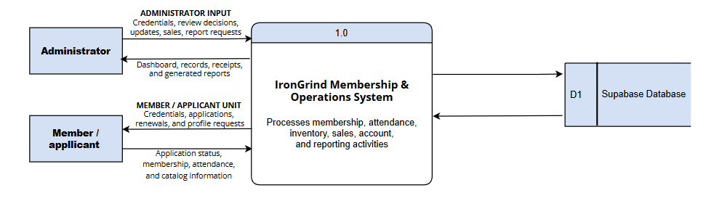
Context Diagram
Figure 2. Context
Figure 2 shows how the Administrator and the Member / Applicant exchange information with the IronGrind Membership and Operations System. The rectangular boxes represent the users who interact with the system. The numbered process, 1.0, represents the system as a whole, while data store D1 represents the Supabase Database. The arrows indicate the direction of information flow.
The Administrator provides sign-in credentials, application review decisions, operational updates, sales entries, and report requests. The system returns dashboard information, records, receipts, and reports. The Member / Applicant provides sign-in credentials, registration and membership application details, renewal requests, and profile requests. In return, the system provides application status, membership and attendance information, and the active product catalog. Process 1.0 saves and retrieves the membership, application, attendance, inventory, and sales records needed to support these functions. Walk-in purchases are entered by the Administrator; walk-in customers do not access the system directly.

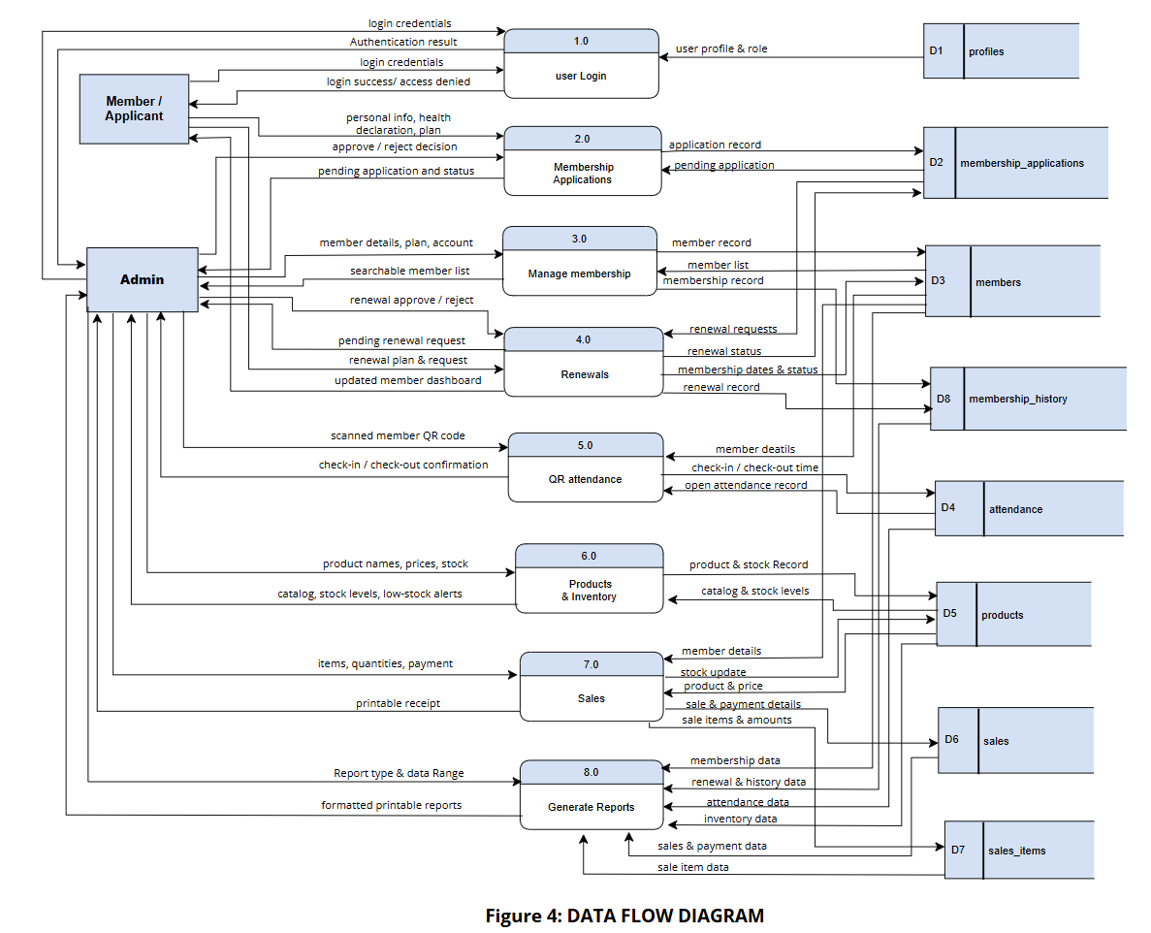
Data Flow Diagram
Figure 3. Data Flow
The Data Flow Diagram (DFD) illustrates the flow of data and the processes involved in the IronGrind Gym Management System. It shows how data moves between the users and the system, and how the system stores and retrieves the information needed for the handling of memberships, renewals, attendance, products, sales, and reports. The diagram has two external entities, the Admin / Staff and the Member / Applicant, eight main processes, and eight data stores (D1 to D8). Each process plays an important role in ensuring that data is accurately recorded, securely stored, and retrieved when needed. The following describes each process in the diagram.

- User Login
This process allows the Admin / Staff and the Member to securely access the system based on their roles. The user enters their login credentials (email and password), which are verified by the system. The process then retrieves the user profile and role from the profiles data store (D1). Once verified, the system returns an authentication result: a successful login that opens the dashboard for the user's role, or an access denied message if the credentials are invalid or the role is not permitted.
2.0 Membership Applications
This process handles the online registration of new members. The Applicant submits personal information, health declarations, and the chosen membership plan, which the system saves in the membership applications data store (D2). The Admin / Staff receives the list of pending applications, reviews each one, and sends an approve or reject decision. The system then updates the application record in D2 with the new status, so that every application has a clear and traceable result.
3.0 Manage Membership
This process allows the Admin / Staff to add and maintain member records, especially during walk-in registration. The Admin / Staff enters the member's details, including contact information, emergency contacts, membership plan, and status, and can also create the member account. The system stores this information in the members data store (D3) and records it in the membership history data store (D8). The system also retrieves data from D3 to display a searchable list of active and expired members for the Admin / Staff.
4.0 Renewals
This process handles the renewal of existing memberships. Members may submit a renewal request at any time, subject to administrator approval. If approved while the membership is active, the renewed period begins after the current expiry date, preserving unused membership time. If approved after expiration, the renewed period begins on the approval date. The system records the request in the membership applications data store (D2). The Admin / Staff reviews the pending renewal requests and inputs an approval or rejection. Once a request is approved, the system updates the membership dates and status in the members data store (D3), saves a renewal record in the membership history data store (D8), and updates the Member's dashboard to show the new membership details.
5.0 QR Attendance
This process records the attendance of members inside the gym. The Admin / Staff scans the member's system-generated QR code using a device camera. The system retrieves the member's details from the members data store (D3) to validate the member, and checks the attendance data store (D4) for an open attendance record to determine whether the scan is a check-in or a check-out. The system then logs the timestamp in D4 and displays a real-time confirmation of the successful check-in or check-out.
6.0 Products & Inventory
This process allows the Admin / Staff to maintain the supplement catalog and the merchandise inventory. The Admin / Staff inputs product names, prices, categories (supplement or merchandise), and stock quantities for merchandise. The system saves these records in the products data store (D5), where supplements are sold by gram and merchandise is tracked by item and stock quantity. The system retrieves the current catalog and stock levels from D5 and displays them to the Admin / Staff, together with alerts for low-stock merchandise.
7.0 Sales
This process records in-person transactions for memberships and products, including walk-in customers. The Admin / Staff selects the products or membership being purchased, enters the quantities in grams or pieces, and records the payment. The system retrieves member details from the members data store (D3) and the product and price information from the products data store (D5). It then saves the sale and payment details in the sales data store (D6), saves the individual items and amounts in the sale items data store (D7), and updates the stock in D5. Finally, the system generates a printable receipt for the completed transaction.
8.0 Generate Reports
This process generates reports requested by the administrator. The administrator selects a report type and report month. The system retrieves the relevant membership, attendance, inventory, sales, and membership history records. Dated reports show records for the selected month, while Member Status and Inventory reports show current records. Reports can be previewed, printed, downloaded individually as PDFs, or exported together as a ZIP file.

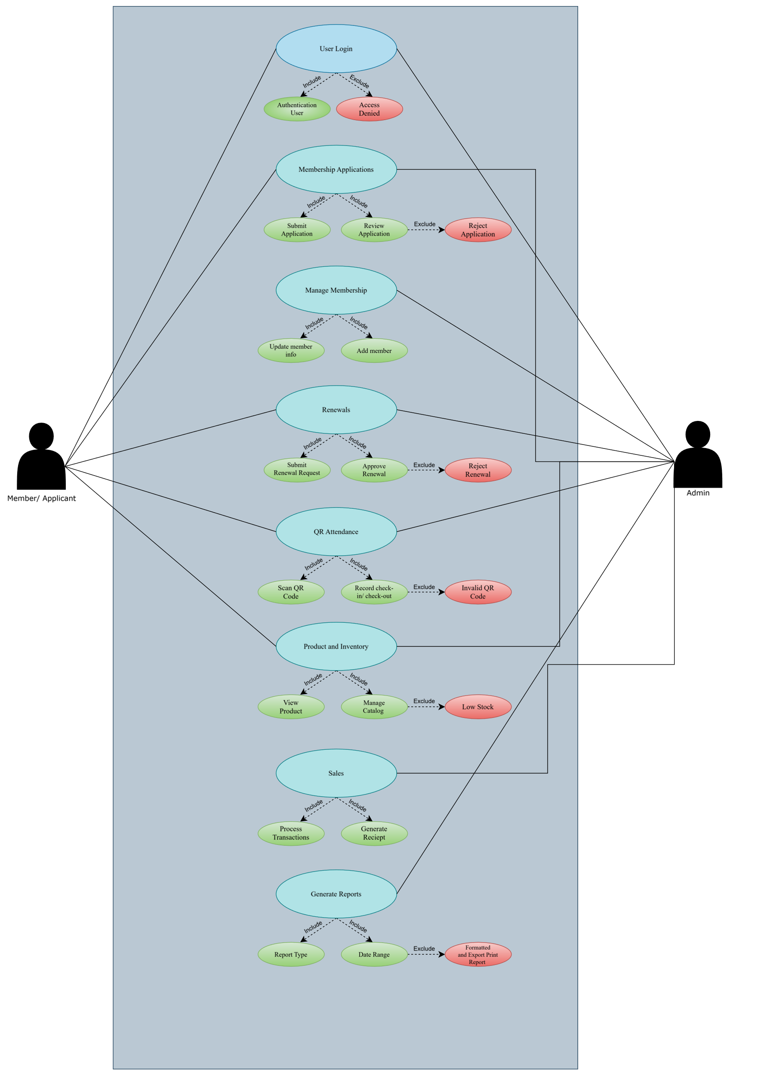
Use Case Diagram
Figure 4. Use Case
The Use Case model of the system presents a clear visualization of how the user interacts with the system's main functions and features. It identifies the primary actors, which are the User and the Admin, along with the various use cases or processes the user is allowed to perform within the system.
These use cases outline the specific actions, such as managing membership information, updating records, and generating reports, that contribute to the system's overall functionality. The object model ensures that all necessary functions are clearly defined, organized, and accessible only to authorized users to maintain security and accuracy.
It also serves as a blueprint for system design, making it easier to implement, test, and maintain the system. By providing a structured representation, the model minimizes potential errors and ensures that all user requirements are addressed.
Overall, it enhances both the clarity and efficiency of system development and management. As shown in Figure 4, the User and the Admin are the primary actors who have control over the system operations and serve as the central point of interaction within the platform.
The User is responsible for managing their personal profile, submitting membership applications and renewals, and viewing their attendance history.
The Admin, on the other hand, handles the review of applications, recording of attendance via QR scanning, managing product inventory, processing walk-in sales, and generating operational reports.
Each of these processes represents a key function of the system, ensuring that gym information is accurately maintained, updated, and easily accessible. These tasks also demonstrate how the system supports efficient documentation, organized data management, and streamlined workflow for gym operations.

1. Authenticate Account
This function verifies the user’s email address and password through Supabase Auth. The system checks the associated profile role to provide access to the appropriate administrator or member dashboard.
2. Register and Submit Membership Application
This function allows the User to create an account and submit their personal and health information, which is then sent to the Admin for review.
3. Review Membership Applications
The Admin can view the submitted applications and make a decision to either approve or reject them based on the gym's criteria.
4. Create Membership Account
Once an application is approved, this function allows the Admin to generate the official member record with the assigned start and expiry dates.
5. View Application status at Login
The User can check the real-time status of their membership application upon logging in to see if it is pending, approved, or rejected.
6. View Membership Dashboard
This function allows the User to access their personalized dashboard, displaying their active membership plan, time-based progress, and their unique QR code.
7. Manage Member and Membership Records
The Admin can view, update, search, and archive member profiles and membership histories to keep the database organized.
8. Record Membership Attendance
This function allows the Admin to scan the User's QR code to accurately record their check-in and check-out times in the system.
9. View Personal Attendance History
The User can view a detailed log of their own gym visits, including the dates and exact times they entered and exited the gym.
10. Manage Profile
This function allows the User to update their personal information, contact details, and account settings securely.
11. Browse Active Product Catalog
The User can view the available supplements and merchandise sold by the gym.
12. Manage Products and Inventory
The Admin can add, update, and monitor the product catalog, ensuring that merchandise stock quantities and supplement details are accurate.
13. Record Walk-In Product Sale
The Admin can process in-person transactions for both members and walk-in customers, generating printable receipts and automatically deducting stock.
14. Submit Membership Renewal Request
This function allows a member to submit a renewal request at any time, subject to administrator approval. If approved while the membership is active, the new membership duration is added after the current expiry date. If approved after expiration, the renewed period begins on the approval date.
15. View Dashboard and Operational Reports
The Admin can view a summarized dashboard showing active members, daily sales, and attendance, as well as access specific operational reports.
16. Export Reports
This function allows the Admin to generate, download, or print detailed reports for record-keeping and business analysis.
17. Email Notifications (In Development)
As indicated by the dashed yellow elements in Figure 4, the system includes planned functions to Notify Membership Approval, Notify Renewal Approval, and Notify Membership Expiration. As stated in Chapter 1, these notification features and the external email provider are not yet part of the current version.

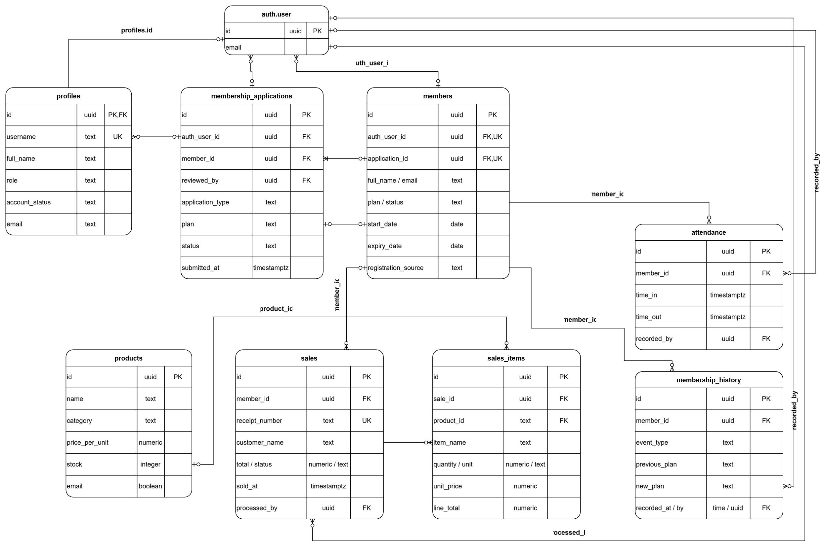
Entity Relationship Diagram
Figure 5. ERD
The Entity Relationship Diagram (ERD) of the IronGrind System shows the overall structure of the database and how the data in the system are connected to each other. It helps in organizing, storing, and retrieving information efficiently. The ERD is important because it guides the proper design of the database and prevents duplication or loss of data.

1. auth.users Entity
This entity serves as the primary authentication table for the system. It stores the unique identifier (id) and email address of every user. This entity is crucial for system security, ensuring that only individuals with verified credentials can log in and access the system.
2. profiles Entity
The Profiles table manages the specific system roles and account statuses. It is linked directly to the auth.users table through a foreign key (id). It stores the user's username, full name, role (Admin or Member), and email. This table ensures that the system knows what type of dashboard to show the user upon logging in.
3. membership_applications Entity
This table stores data from new applicants and renewal requests awaiting admin review. It tracks the application type, selected plan, current status, and submission time. It links to the user applying (auth_user_id) and the admin who reviewed it (reviewed_by).
4. members Entity
The members table stores each member’s personal information, current membership plan, membership dates, status, and registration source. It links to the member’s Supabase Auth account and may reference a registration application. The application reference can be empty for members created directly by an administrator.
5. attendance Entity
Records all gym visits. It contains foreign keys linking to the specific member who visited (member_id), the exact check-in and check-out times (time_in, time_out), and the staff member (recorded_by) who processed the QR scan.
6. products Entity
Stores information on gym items. It differentiates between supplements (priced per gram) and merchandise (tracked with a stock quantity). It includes the product name, category, price per unit, and active status.
7. sales Entity
Records the header information for all transactions. It tracks the member (if applicable), customer name, receipt number, total amount, date sold, and the staff member (processed_by) who handled the transaction.
8. sale_items Entity
This table acts as a junction linking specific products to a sale. It records the item name, quantity/unit, unit price, and line total for every item included in a single receipt. It connects the sales table to the products table.
9. membership_history Entity
This table tracks the lifecycle of a member's plan. It records events such as renewals or plan changes, storing the previous plan, new plan, and the timestamp of when it was recorded, along with the admin (recorded_by) who made the change.
Profile to Members. A user account may be linked to at most one member record. Administrator accounts and applicants awaiting approval may have no linked member record.
Members to Membership Applications. This is a one-to-many relationship: a member can have multiple membership applications over time, including renewal requests. Each application may reference one member. A pending registration application can exist without a linked member record until it is processed.
Members to Attendance. This is a one-to-many relationship because a member can have multiple attendance logs (check-ins) over their membership period, but each attendance record is tied to only one member.
Members to Sales. This is a one-to-many relationship because a member can make multiple product purchases (sales), but each sale is tied to only one member (if it is not a walk-in).
Members to Membership History. This is a one-to-many relationship because a member can have multiple history records (renewals, plan changes) over time, but each history record is linked to only one member.
Sales to Sale_Items. This is a one-to-many relationship because a single sales transaction can contain multiple items (sale_items), but each sale_item belongs to only one sale.
Products to Sale_Items. A product can appear in multiple sale items. Each sale item may reference one product, while membership charges have no product reference. The item name and price are retained as transaction snapshots
Auth Users to All Tables. The auth.users table has a one-to-many relationship with system logs, acting as the recorded_by or processed_by foreign key for attendance, sales, and membership history, tracking which admin performed the action.
Overall Description
This Entity Relationship Diagram (ERD) presents the organized structure of how gym operations and member information are managed within the system. Member data serves as the main component and is supported by linked information stored in the membership applications, attendance, sales, and membership history tables. These relationships ensure that all relevant data connected to each member record is properly tracked and maintained. The auth.users and profiles entities oversee system access and operations, ensuring security, accuracy, and efficient management of all gym information stored in the database, while the products and sale_items tables handle the physical inventory and point-of-sale transactions.

Data Dictionary
The Data Dictionary provides detailed information about all the data elements used in the system. It defines each table, its fields, data types, lengths, keys, and a short description of their purpose. This ensures that data is structured consistently, relationships are clearly identified, and database operations are properly managed.
Each table in the database represents a specific entity within the system. The following are the detailed descriptions of all tables and their corresponding fields, providing clearer understanding and structure.

Table 6: profile
Stores application-facing account details and the user's access role. Each profile uses the same identifier as its Supabase Auth account, with account status available in deployments that include that field.
Field Name | Field Type | Length | Key | Description
id | uuid |  | PK | Account identifier shared with Supabase Auth.
email | text | 254 |  | Account email, synchronized from Supabase Auth.
username | text | 30 |  | Application username; availability checks compare case-insensitively.
Full_name | text | 150 |  | Display name associated with the account.
role | text | 20 |  | Controls application administrator or member access
account_status | text |  |  | Optional live-schema field where deployed. Represents the account availability state.
Created_at | timestamptz |  |  | Profile creation time.
Updated_at | timestamptz |  |  | optional live-schema field where deployed. Records the most recent profile update time.

Table 7: members
Stores each gym member's current personal details and membership information. Previous membership changes are recorded separately in `membership_history`.
Field Name | Field Type | Length | Key | Description
id | uuid |  | PK | Internal member identifier.
Auth_user_id | uuid |  | FK | References the member’s Supabase Auth account. A partial unique index permits at most one member record per linked Auth account.
Application_id | uuid |  | FK | Registration application associated with the member record. It can be empty for members created by an administrator
Full_name | text | 150 |  | Member's full name
email | text |  |  | Member contact email; synchronized from Auth when linked.
username | text | 30 |  | Member's application username, when available.
mobile | text | 11 |  | Member contact number; profile updates validate Philippine mobile format.
Date_of_birth | date |  |  | Member's birth date.
age | smallint |  |  | Age value captured or calculated by profile updates.
sex | text | 30 |  | Member-provided sex value.
height | numeric | 7, 2 |  | Height measurement; unit is stored separately.
Height_unit | text | 3 |  | Unit for `height.
Weight_kg | numeric | 7, 2 |  | Weight in kilograms.
Emergency_contact | jsonb |  |  | Structured emergency-contact details.
plan | text | 30 |  | Current membership plan name.
plan_price | numeric | 12, 2 |  | Current membership price.
start_date | date |  |  | Start date of the current membership period.
expiry_date | date |  |  | Canonical membership expiry date.
end_date | date |  |  | Compatibility date retained by membership operations; may be used when ‘expiry_date’ is empty.
status | text | 20 |  | Current member/membership status.
registration_source | text |  |  | Origin of the member record.
paid | boolean |  |  | Whether the membership payment has been recorded as paid.
fitness_goals | text[] |  |  | List of member fitness goals.
health_conditions | text[] |  |  | List of declared health conditions.
Other_medical_conditions | text |  |  | Additional medical information.
Signature_path | text |  |  | Storage path or reference for the member's signature asset.
Created_at | timestamptz |  |  | Member record creation time.
Updated_at | timestamptz |  |  | Most recent member record update time.

Table 8: membership_application
Stores submitted registration and renewal requests with the information provided by the applicant. Review status, reviewer, and timestamps track each request through processing.
Field Name | Field Type | Length | Key | Description
id | uuid |  | PK | Application identifier.
auth_user_id | uuid |  | FK | Auth account that submitted the request.
member_id | uuid |  | FK | Existing member associated with a renewal or processed application.
Application_type | text | 20 |  | Distinguishes new-member registration from renewal.
Full_name | text | 150 |  | Applicant/member name submitted with the request.
email | text | 254 |  | Email captured with the application.
username | text | 30 |  | Username captured with the application.
mobile | text | 11 |  | Contact number submitted by the applicant.
Date_of_birth | date |  |  | Applicant's birth date.
age | smallint |  |  | Applicant's age.
sex | text | 30 |  | Applicant-provided sex value.
Height | numeric | 6, 2 |  | Height measurement; unit is stored separately.
Height_unit | text | 3 |  | Unit for `height`.
Weight_kg | numeric | 6, 2 |  | Weight in kilograms.
Emergency_contact | jsonb |  |  | Emergency contact in the main application payload.
Emergency_contact_data | jsonb |  |  | Compatibility emergency-contact payload; not automatically synchronized with `emergency_contact`.
plan | text | 30 |  | Membership plan requested.
Plan_price | numeric | 10, 2 |  | Price submitted for the requested plan.
start_date | date |  |  | Requested membership start date
end_date | date |  |  | Requested membership end date
fitness_goals | text[] |  |  | Applicant's fitness goals.
health_conditions | text[] |  |  | Applicant's declared health conditions.
Other_medical_conditions | text |  |  | Additional medical information.
Signature_path | text |  |  | Storage path or reference for the submitted signature.
status | text | 20 |  | Application review status: pending, approved, or rejected.
submitted_at | timestamptz |  |  | Submission timestamp.
reviewed_at | timestamptz |  |  | Time the application was reviewed.
reviewed_by | uuid |  | FK | Auth account of the reviewer.

Table 9: attendance
Stores one record for each member visit to the gym. Check-in and optional check-out timestamps support attendance history and visit tracking.
Field Name | Field Type | Length | Key | Description
id | uuid |  | PK | Attendance record identifier.
member_id | uuid |  | FK | Member who attended; referenced members cannot be deleted.
time_in | timestamptz |  |  | Member check-in time.
time_out | timestamptz |  |  | Member check-out time; NULL can indicate an open visit or missing check-out.
recorded_by | uuid |  |  | Staff account that recorded the attendance event.
created_at | timestamptz |  |  | Attendance row creation time.

Table 10: products
Stores products offered for sale, including prices, units, and inventory information. Active and archived product records support catalog management and sales history.
Field Name | Field Type | Length | Key | Description
id | uuid |  | PK | Product identifier.
name | text | 120 |  | Product display name.
category | text | 20 |  | Determines product type and inventory behavior.
price_per_unit | numeric | 12, 2 |  | Price for one stored unit (gram or item).
unit | text | 12 |  | Unit in which the product is sold. Supplements use `gram`; merchandise uses `item`
size | text | 30 |  | Optional product size or package description.
stock | integer |  |  | Merchandise quantity on hand. Supplements use NULL stock; sale operations expect merchandise stock to be set.
image_path | text |  |  | Storage path or reference for the product image.
is_active | boolean |  |  | Whether the product is currently offered for sale.
archived_at | timestamptz |  |  | Time the product was archived, if applicable.
created_at | timestamptz |  |  | Product creation time.
updated_at | timestamptz |  |  | Most recent product update time.

Table 11: sales
Stores one record for each receipt-level transaction. It captures the customer, total, sale status, and staff account that processed the transaction.
Field Name | Field Type | Length | Key | Description
id | uuid |  | PK | Sale identifier.
receipt_number | text | 64 |  | Human-readable receipt identifier.
customer_type | text | 15 |  | Identifies the customer category.
customer_name | text | 150 |  | Customer name saved on the receipt.
member_id | uuid |  |  | Member associated with the transaction; NULL for walk-in sales.
total | numeric | 10, 2 |  | Total transaction amount.
status | text | 12 |  | Indicates the transaction’s payment status. The compatibility migration normalizes stored status values to lowercase.
sold_at | timestamptz |  |  | Time of sale.
processed_by | uuid |  | FK | Auth account of the staff member who processed the sale.

Table 12: sale_items
Stores each product or membership charge associated with a sale. Item name and price are retained as a transaction snapshot if the catalog record later changes or is removed.
Field Name | Field Type | Length | Key | Description
id | uuid |  | PK | Sale-line identifier.
sale_id | uuid |  |  | Parent receipt; deleting a sale deletes its line items.
product_id | uuid |  |  | Catalog product represented by this line, if applicable.
item_name | text | 150 |  | Item/plan name snapshot printed on the receipt.
category | text | 20 |  | Type of item charged.
quantity | numeric | 12, 3 |  | Sold quantity, supporting fractional gram amounts.
unit | text | 12 |  | Unit used for the line quantity
unit_price | numeric | 12, 2 |  | Price charged per unit of the product or membership item.
line_total | numeric | 12,2 |  | Total amount charged for the sale item based on its quantity and unit price.

Table 13: membership_history
Stores membership lifecycle events and the relevant membership values before and after each event. These records support administrative review and reporting without replacing the member's current details.
Field Name | Field Type | Length | Key | Description
id | uuid |  | PK | History event identifier.
member_id | uuid |  |  | Member whose membership changed; referenced members cannot be deleted.
event_type | text |  |  | Type of lifecycle event recorded.
previous_plan | text |  |  | Plan before the event
new_plan | text |  |  | Plan after the event.
previous_price | numeric | 12, 2 |  | Price before the event.
new_price | numeric | 12, 2 |  | Price after the event.
previous_start_date | date |  |  | Membership start date before the recorded event.
previous_expiry_date | date |  |  | Membership expiry date before the recorded event.
new_start_date | date |  |  | Membership start date after the event.
new_expiry_date | date |  |  | Membership expiry date after the event.
notes | text |  |  | Additional event context, such as a receipt reference.
recorded_at | timestamptz |  |  | Time the event was recorded.
recorded_by | uuid |  |  | Auth account that recorded the event.

Forms

The Iron Grind Fitness Gym Membership and Operations Management System uses forms to collect and manage the information needed for membership and daily gym operations. Members use the registration form to provide personal and emergency-contact details, choose a membership plan, declare health conditions and fitness goals, accept the gym’s policies, sign the application, and create login credentials. Once registered, they can use account settings to review or update their profile and the renewal form to submit a request to continue their membership. Administrators use forms to add member records, review registration and renewal applications, change membership plans, and record payments. They also use the inventory forms to add or update products and stock information, and the sales form to record walk-in purchases. Completed transactions can be reviewed through the system’s sales records and receipts. Required fields and input validation help prevent missing or incorrectly formatted information. Organizing entries through dedicated forms reduces reliance on paper records and makes information easier to retrieve and update. This helps administrators handle applications, memberships, inventory, and sales more consistently, while giving members a convenient way to submit information and requests.

Prototype


Figure 6. log-in dashboard
Login Members and admins sign in here. New members can open the registration form, and existing users can recover a forgotten password.



Figure 7. Member Registration dashboard
Membership Registration The upper section collects personal details, emergency contact, plan, health information, and goals. The lower section contains agreements, signature, and account credentials. Submissions go to the admin for review.



Figure 8. Admin dashboard
Admin Dashboard Shows a quick summary of current members, today’s visits and sales, and low-stock products. The sidebar opens the admin pages.



Figure 9. Membership Management dashboard
Membership Management Searches and filters members by plan. Admins can add members, change plans, renew memberships, and review pending applications.



Figure 10. Attendance & QR dashboard
Attendance & QR Staff scan a member’s QR code to check them in. Scanning again checks them out. The log shows visits for the selected date.



Figure 11. Store & Inventory dashboard
Displays products and lets staff add, edit, or archive them, or start a walk-in sale.



Figure 12. Sales (Memberships)
The Memberships view displays paid membership income and transaction counts for a selected month, grouped by Monthly, Half Month, Daily Walk-in, and other plans. Administrators can filter the transaction records by plan and view or print individual receipts.



Figure 13. Sales (Products)
The Products view displays daily product income, including supplement and merchandise income, for a selected date. Administrators can filter product transaction records by category or product, review individual receipts, and record new product sales.



Figure 14. Reports dashboard
Reports Provides membership, attendance, sales, renewal, archive, and inventory reports. Reports can be viewed, printed, saved as PDFs, or exported together.



Figure 15. Report Preview
Report Preview Shows a report inside the app. Users can scroll, zoom, or close the preview.



Figure 16. Final Report Print
Final Report Print Preview Shows how the report will appear on the page before saving or printing.



Figure 17. Member dashboard
Member Dashboard Members can check their plan, expiry, progress, attendance, renewal options, products available at the gym, and personal QR code.



Figure 18. Member Account Settings
Account Settings Lets members review or update personal, emergency-contact, fitness, and health details.

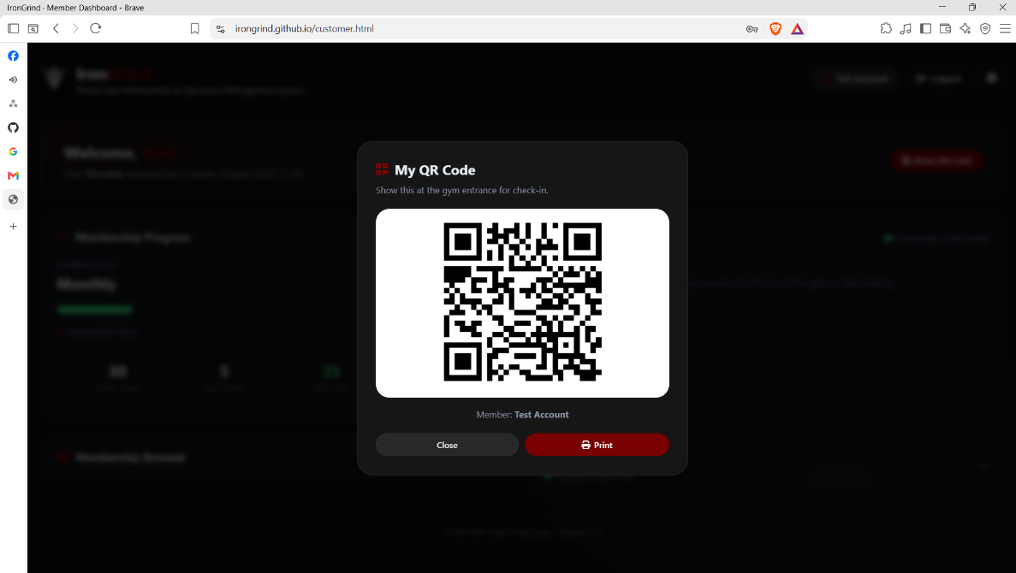

Figure 19. Member QR Code
Member QR Code The member presents this code at the gym so staff can record attendance.

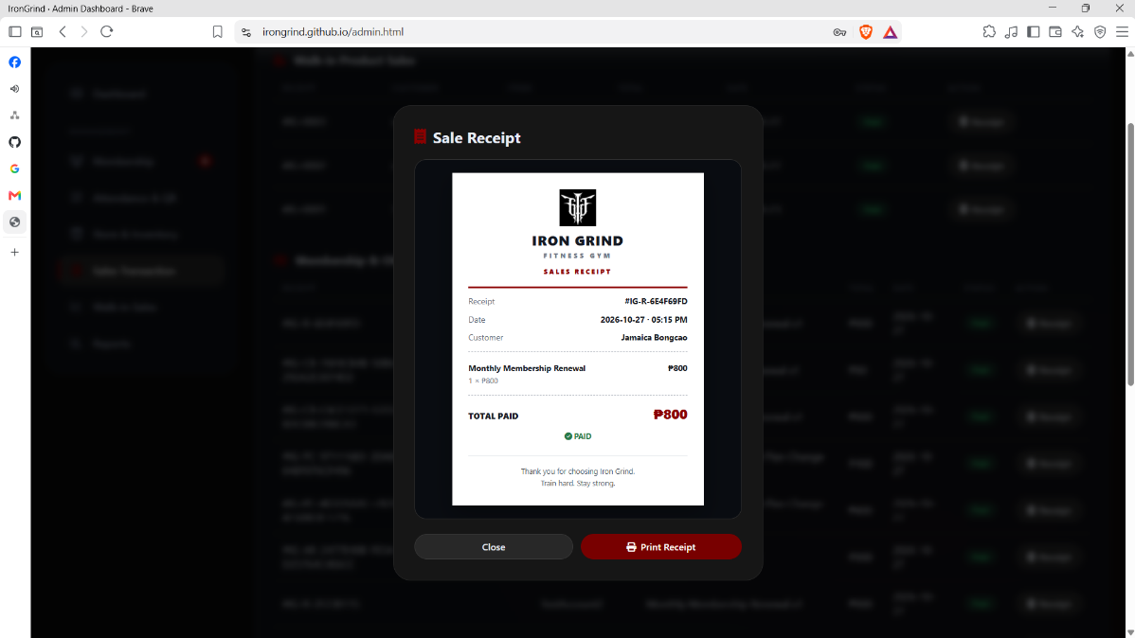

Figure 20. Receipt
Receipt Show a recorded sale or renewal with its receipt number, customer, items, amount, and payment status. Staff can print or save it

Gantt Chart


Figure 21. Gantt Chart
The Gantt chart presents the planned development schedule for the Iron Grind System over ten weeks, from August 24 to October 28. The work is organized into three phases. During Planning (Weeks 1–4), the team identifies a potential client, interviews the client, gathers feedback, and confirms the system requirements and proposed features. During Design (Weeks 5–8), the team creates and refines the user-interface design and prototypes using the requirements and feedback gathered during planning. During Development (Weeks 9–10), the team begins implementing the frontend, backend, database, API, and supporting components while continuing work on the project chapters. The phases show how the project moves from understanding the gym’s needs to designing and developing the system.

